6719 Lowell Avenue, McLean, VA 22101
Phone: 703-356-5582 Fax: 703-893-2441
E-mail: info@odahcenter.com
Website: www.odahcenter.com
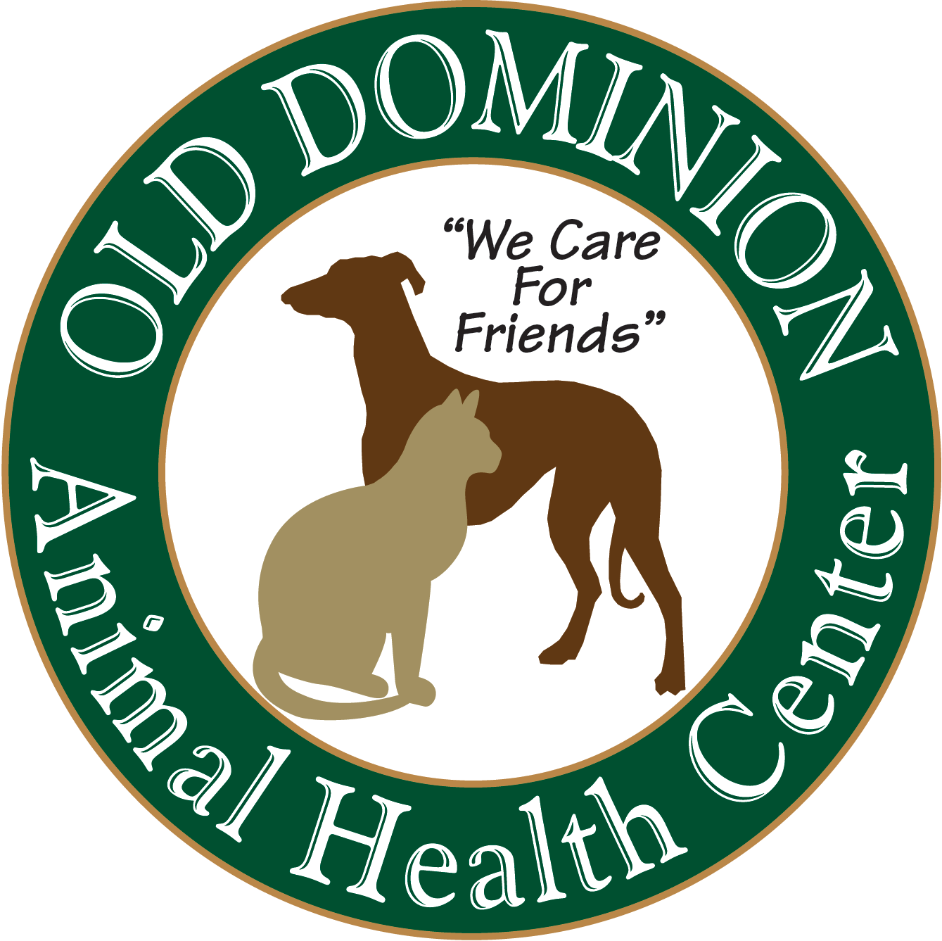 BOARDING AUTHORIZATION

ACCOMMODATIONS:
Penthouse Suites (Canine)  Doggie Den  Courtyard Rooms  Canine Cottages Cat Condo
BOARDING INSTRUCTIONS:
I will pick up on: Date________________________________________________________Time________________________________
I can be reached at: _______________________________________ If I cannot be reached, call: _________________________________
Optional Email address, in case we cannot reach you by phone (please print clearly): __________________________________________________
FEEDING INSTRUCTIONS: Own Food Dry Only Canned Only Canned & Dry How Many Feedings Per Day: _______
Instructions: ___________________________________________________________________________________________________________
______________________________________________________________________________________________________________________
MEDICATIONS TO GIVE: (Additional Fees Apply)
1) _________________________________________________________________________ next dose due _______________________
2) _________________________________________________________________________ next dose due _______________________
3) _________________________________________________________________________ next dose due _______________________
4) _________________________________________________________________________ next dose due _______________________

MEDICAL SERVICES REQUESTED (VACCINES WITH AN ASTERISK REQUIRE A PHYSICAL EXAM):
 Update required vaccines, annual test and exam: Canine (Rabies*, DaP* or DHPP*, Leptospirosis*, Bordetella, H3N8 CIV, H3N2 CIV and Fecal test) Feline (Rabies* and HCP* or FVRCP*)
 Please also update all recommended vaccines, annual test and exam: Canine (Lyme vaccine* and Heartworm test)
Feline (Fecal test and Feline Leukemia* vaccine)
 Check vaccine and annual test history at__________________________________________________________________________
 Request Doctor________________to examine (we may need to substitute a doctor) and treat after requested exam or call before treating.

MEDICAL PROBLEMS WE SHOULD BE AWARE OF: ___________________________________________________________________

CAPITOL CANINE CLUB: (Additional Fees Apply)
 Behavioral evaluation  Daily play group (Mon-Sat)
 Selected days (during entire stay) Mon. Tue. Wed. Thur. Fri. Sat.  Selected days (specify dates) _____________________

BATHING INSTRUCTIONS: (Additional Fees Apply)
 Bath (includes nails and ears)  Moisturizer Tooth brushing Dremel nails
 Professional Grooming (by appointment only)  Clip mats  Doctor / Technician to express anal glands

SPECIAL SERVICES: (Additional Fees Apply)
Extra walks 12pm 8pm 11pm Playtime (one on one) 11am 1pm Daily brushing  Nail trim
Daily Pup-Sicle Daily tooth brushing Special ODAHC bedtime snack for dogs/cats

BEDDING AND KENNEL ITEMS: (initial preference)

Initials
YES, my pet can have ODAH Center provided bedding or personal items left with him/her in their kennel. ODAH Center will not be held liable for any injury, illness, or loss that may occur during the boarding period, including but not limited to, loss of personal items, damage to property, injury, illness or death to my dog or other animals due to bedding, clothing, toys, etc.
ITEMS LEFT:__________________________________________________________________________________________________________
_______________________________________________________________________________________________________________________
_______________________________________________________________________________________________________________________

Initials
NO bedding, toys or clothing should be placed in the kennel with my pet(s).

PAGE 1 OF 2
PLEASE COMPLETE OPPOSITE SIDE

BOARDING AUTHORIZATION CONTINUED

MEDICAL EMERGENCY AUTHORIZATION:

I am the owner/authorized agent of the animal described below and authorize Old Dominion Animal Health Center (ODAH Center) to provide services as necessary to preserve the pet’s life and well-being, and I absolve and release ODAH Center from any loss, expense, or liability arising from the performance of these services. In the event of a medical emergency, outside of regular hours, ODAH Center may transport the pet to a 24-hour emergency clinic, and I authorize ODAH Center staff members to grant permission for diagnostics and treatment at that facility until I am able to be contacted. All fees incurred at that 24-hour emergency clinic and/or ODAH Center, as well as all liabilities or losses are the sole responsibility of the owner or agent. I understand that the center is closed and not medically staffed outside of regular business hours.

Initials
* I ALSO ACCEPT THAT ANY MEDICAL CONDITION WE BELIEVE TO BE PUTTING THIS PET IN PAIN OR RISK, INCLUDING INTESTINAL UPSET WILL BE TREATED IMMEDIATELY AT REGULAR HOSPITAL FEES.

VACCINATIONS AND PARASITE PREVENTION AUTHORIZATION:

Initials
I understand that my pet(s) must be current on all required vaccination and be free of fleas and intestinal parasites. I authorize my pet to be vaccinated and treated for fleas and/or intestinal parasites if necessary.

FINACIAL AUTHORIZATION:

Initials
I accept all financial responsibility for the above services, including any emergency clinic fees, and understand that, unless agreed to in advance, these fees must be paid before the pet is released. I also accept that all boarding charges accrue per calendar day.

MULTIPLE PET FAMILY:

Initials
I authorize and instruct ODAH Center to board my pets together in the same space. I absolve ODAH Center from any liability for injury or illness that may occur as a result of this action.

Print pet’s name: _____________________ ____________________Print Owner’s Name: ___________________________________________________

Signature: __________________________________________________________ Date: ______________________________________________

BOARDING AUTHORIZATION

PAGE 2 OF 2

OLD Dominion Animal Health Center 6719 Lowell Ave., McLean, VA 22101

